• • Exercise: Create an ER diagram data model and implement it in MySQL

Task 3 (SHOW DATABASES)

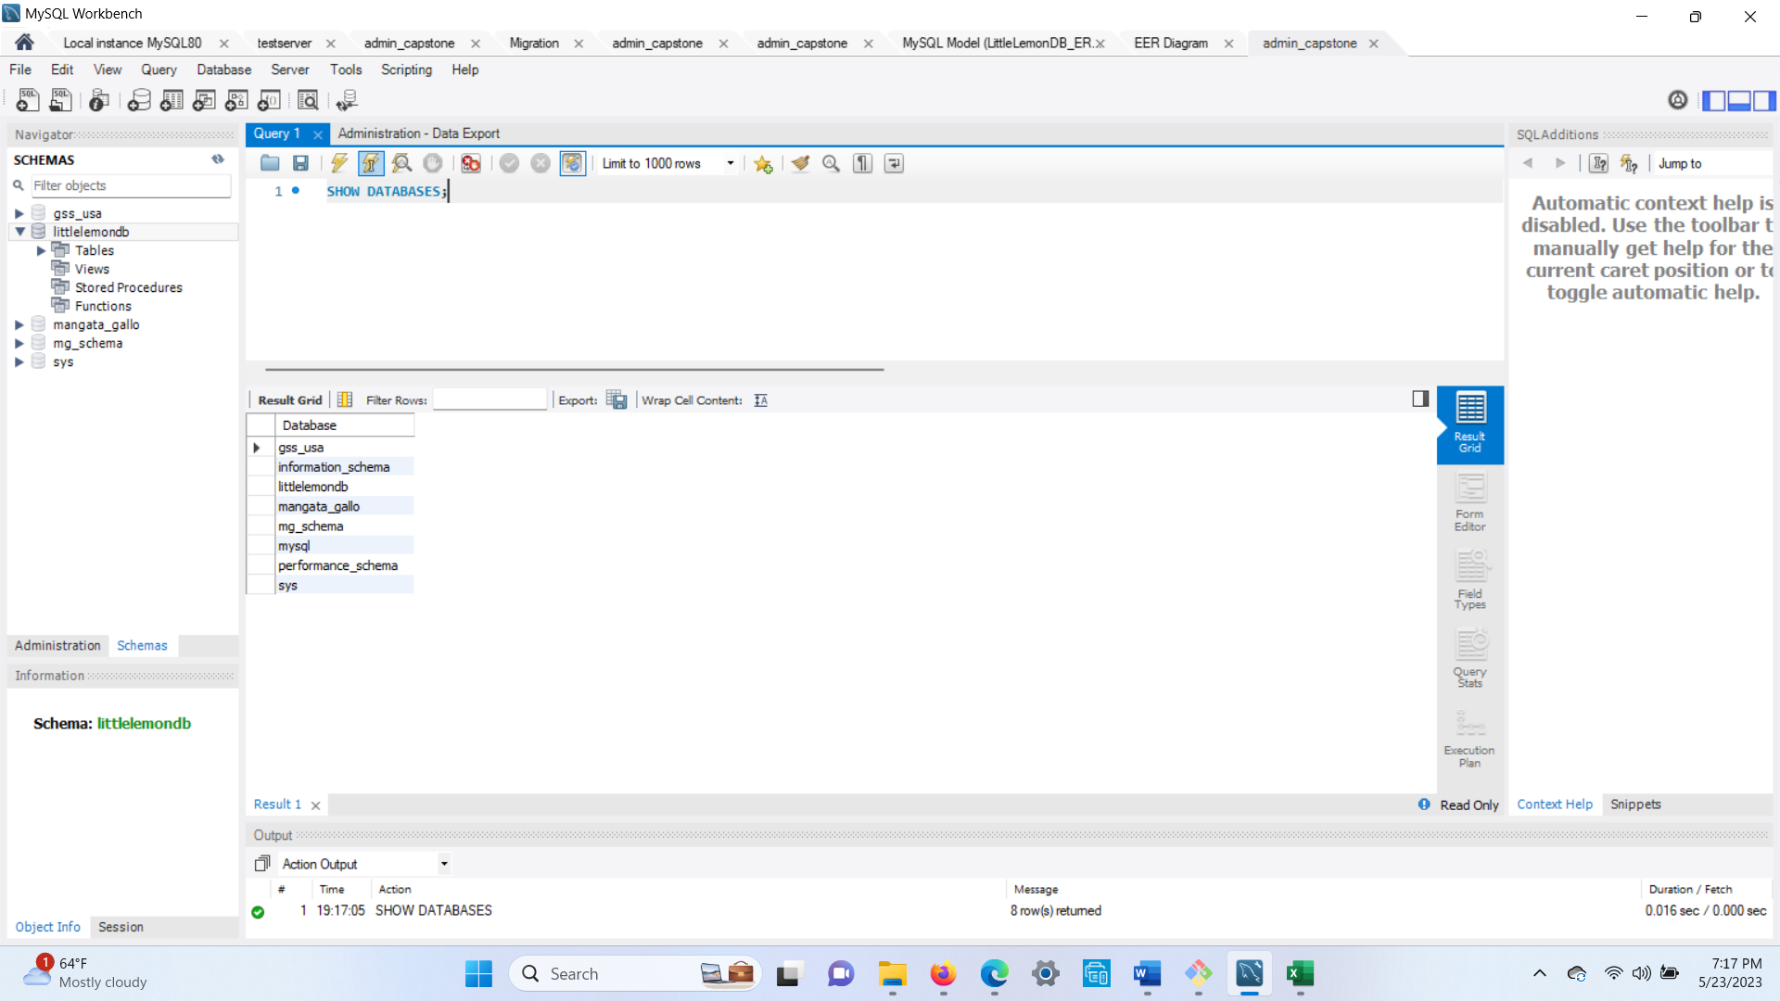

• • Exercise: Create a virtual table to summarize data

Task 1 (Create View)

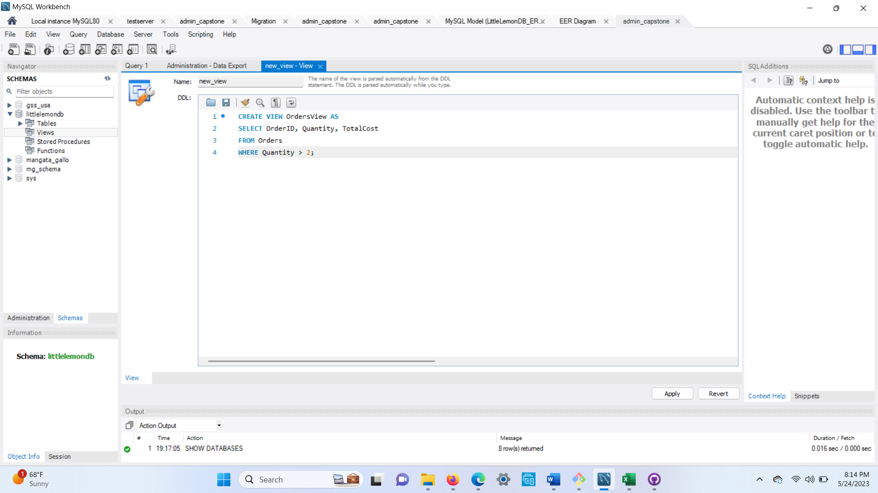

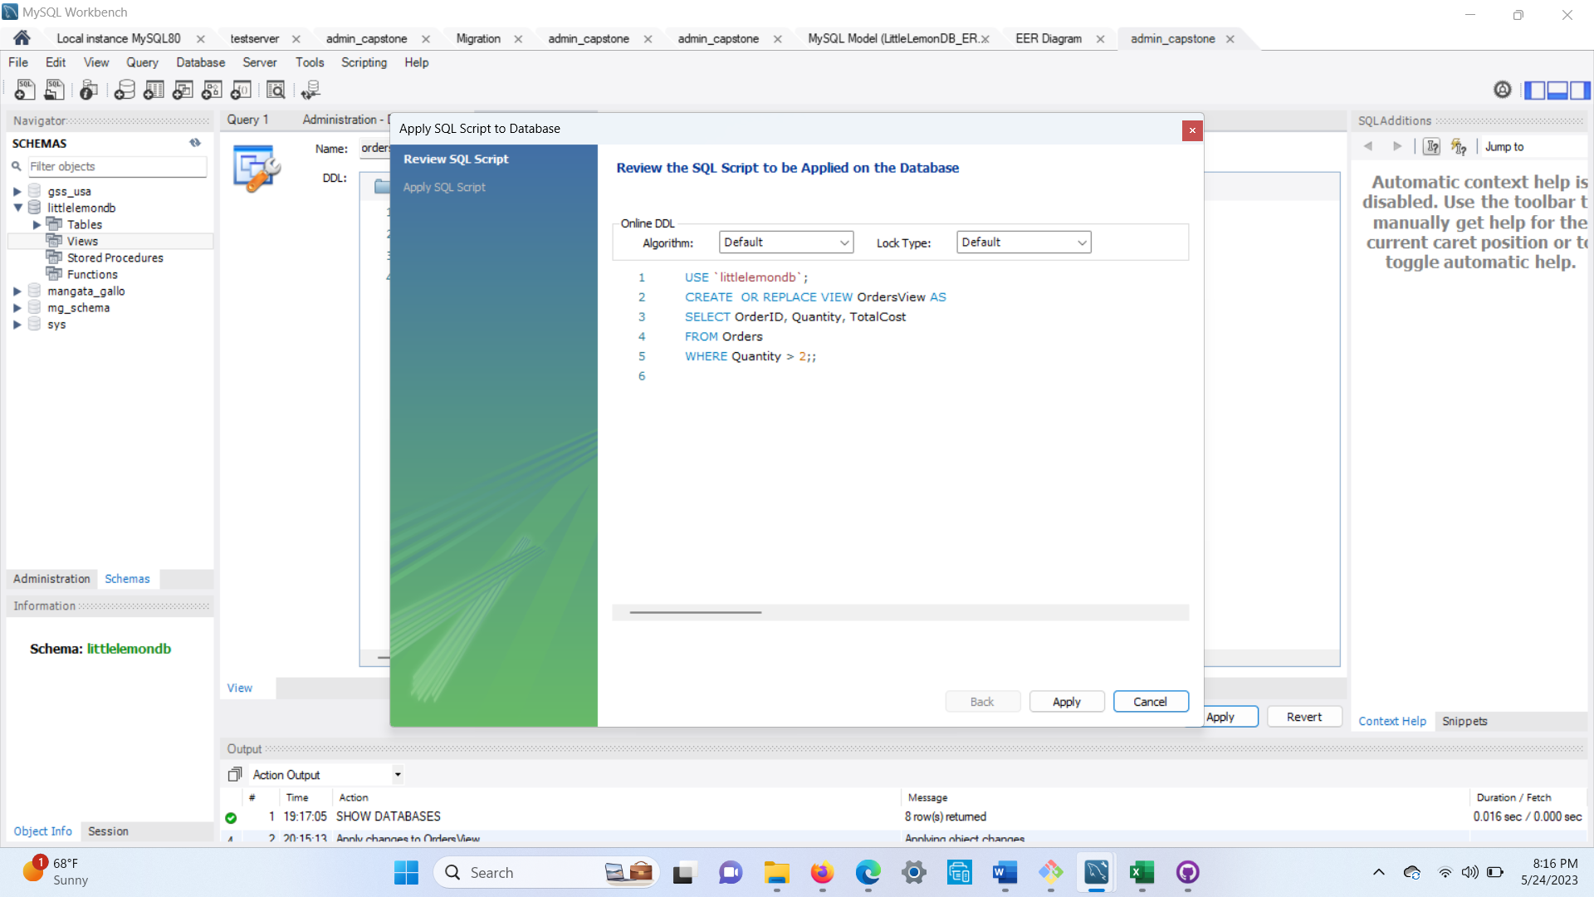

• • Exercise: Create a virtual table to summarize data

Task 2 (JOIN)

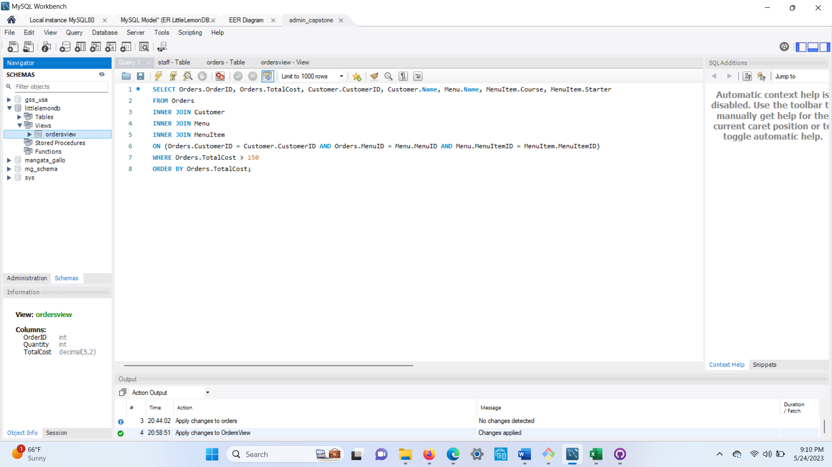

• • Exercise: Create a virtual table to summarize data

Task 3 (subquery)

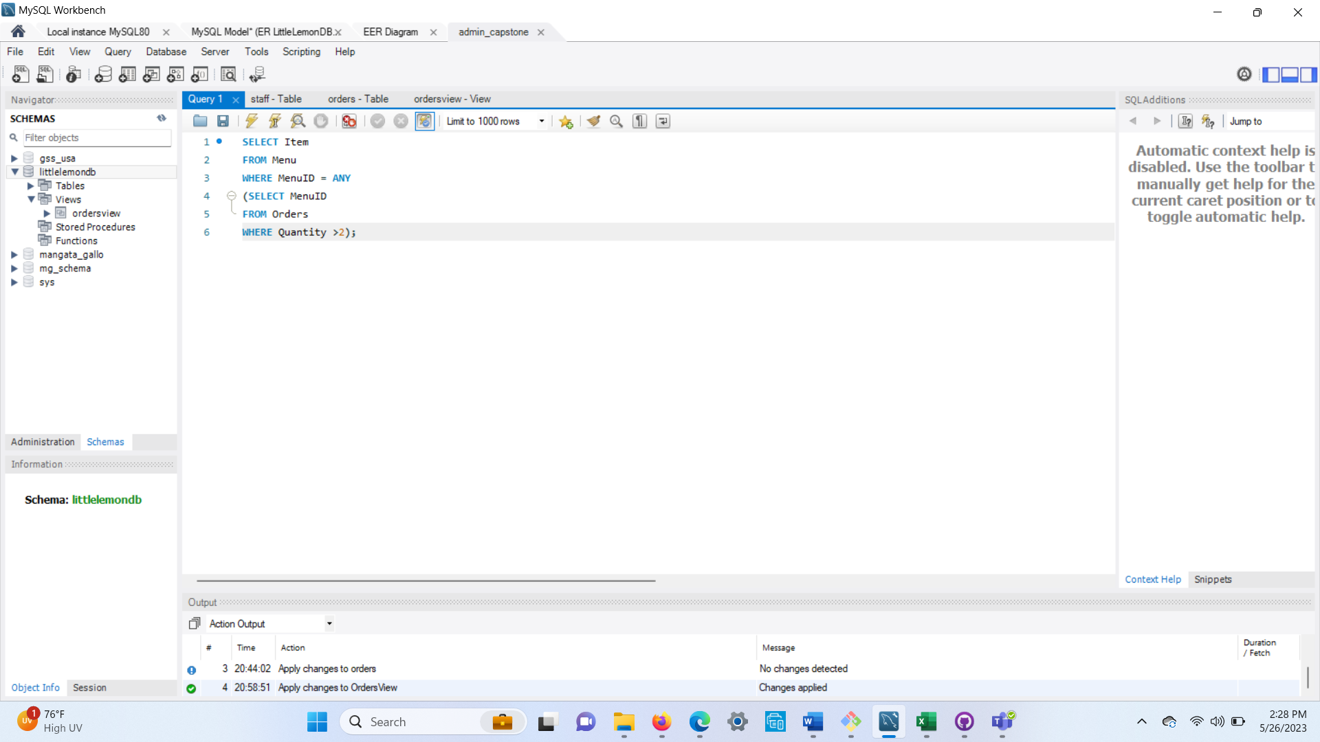

Exercise: Create optimized queries to manage and analyze data

Task 1 (procedure)

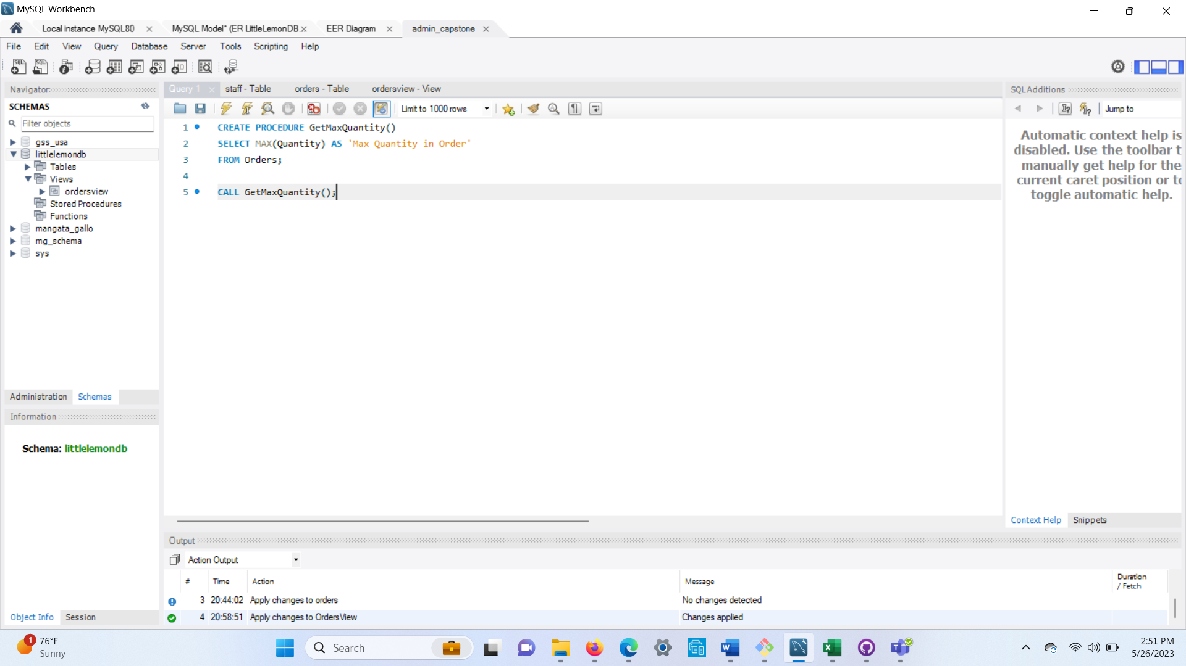

Exercise: Create optimized queries to manage and analyze data

Task 2 (prepared statement)

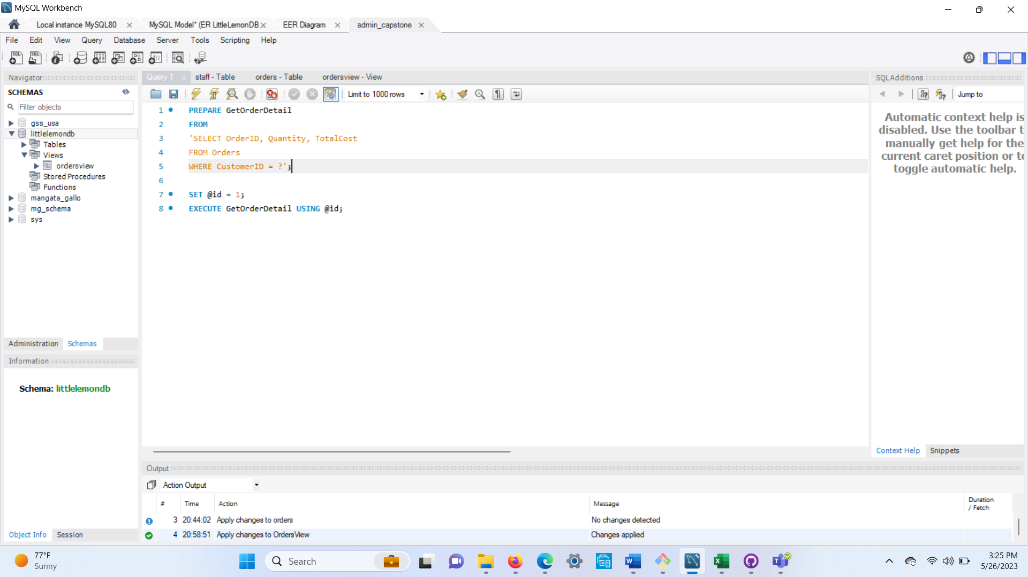

Exercise: Create optimized queries to manage and analyze data

Task3 (procedure)

